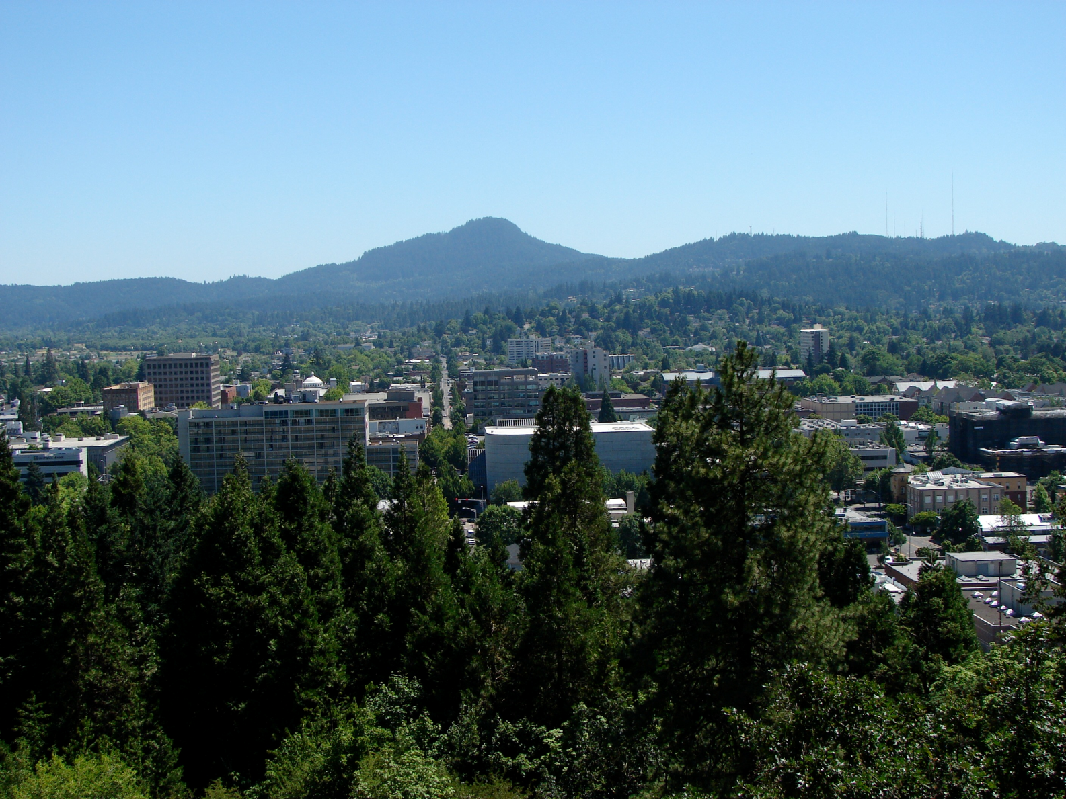

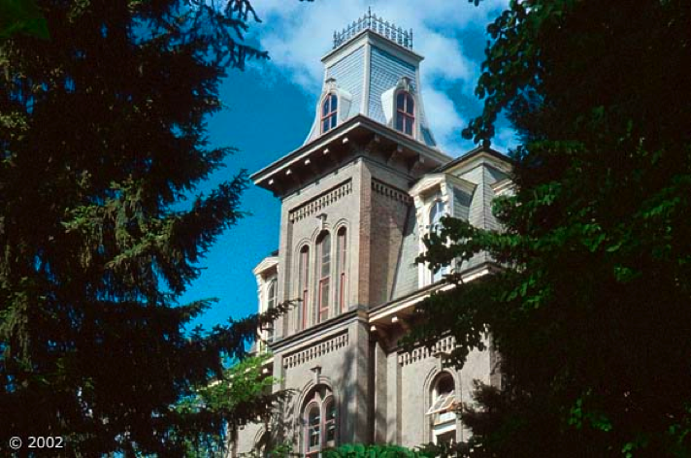

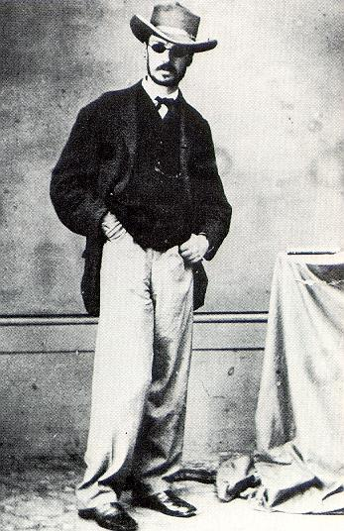

What can pragmatism contribute to contemporary work in ethics and meta-ethics? How can a naturalistic and pragmatist philosophical perspective make productive use of current neuroscience research in order to enrich our understanding of the ethical life? This seminar will work at the intersection of philosophical ethics and contemporary cognitive science in order to address these questions.

Featuring **Mark Johnson** (U Oregon), **Gregory Pappas** (Texas A&M) & **Jay Schulkin** (Georgetown, Department of Neurophysics).

#### **Naturalized Ethics**

Addressing central issues in current philosophy of social science, this panel will both locate areas of potential pragmatist contribution to current debates and refract questions of social science back into pragmatist philosophy. How might engaging the social sciences transform the pragmatist tradition? What must pragmatism become to work well with social sciences?

This seminar will feature **Paul Taylor** (Penn State), **Paul Roth** (UC Santa Cruz), **Alison Wylie** (U Washington) & **Jerry Rosiek** (U Oregon).

For registration & additional program information visit the SIAP website: http://pages.uoregon.edu/koopman/siap/siap_2011.html.

🙞🙜

A one-day Pre-SIAP session on Monday July 11th offering an immersive experience in Deweyan pragmatism. Participants will cook, learn, and share a meal. Space is limited and pre-registration required.

#### **Pre-Institute Seminar: Cooking with Dewey**

This panel will focus on a (re)reading of the work of contemporary philosopher and public intellectual Cornel West, with special attention to West's prophetic pragmatism, its roots in classical American philosophy, and its potentialities for cultural critique today.

This seminar will be led by **Brad Stone** (Loyola Marymount University) and others TBA.

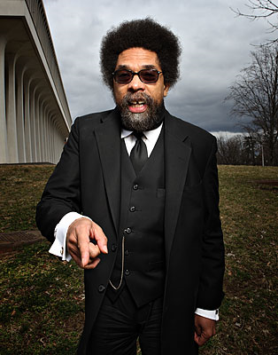

July 11-16, 2011  
at the  
University of Oregon

# **Seminars**

#### **Rereading Cornel West**

### Sponsored by the *Society for the Advancement of American Philosophy* and the University of Oregon Department of Philosophy

#### **Pragmatist Social Science**

# **Seminars**

🙞🙜

Summer Institute in American Philosophy

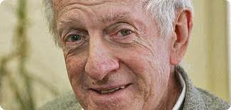

**Joseph Margolis** is the Laura H. Carnell Professor of Philosophy at Temple University. The author of a number of books contributing to nearly every major field of philosophy, he is by all accounts a leading voice on contemporary American Pragmatism. Margolis’ recent trilogy of books on American philosophy places pragmatism in productive conversation with leading trends and figures in both Analytic and Continental philosophy in order to describe the distinctive philosophical requirements that contemporary pragmatism must meet and also why pragmatism is uniquely positioned to rise to these requirements. These books (*Reinventing Pragmatism*, *The Unraveling of Scientism*, & *Pragmatism's Advantage*) form the best recent synopsis of the contemporary philosophical scene with all the strange twists and conceptual coups one could hope for from such an effort.  
  
The title of Margolis' two-session keynote talk will be: "**Pragmatism's Future: A Touch of Prophecy.**"

**About The Summer Institute**

Designed for faculty, advanced graduates, and postdoctoral researchers in philosophy and related disciplines, SIAP offers a unique venue for study of the American philosophic tradition. The program consists of plenary seminars focused on central problem areas or figures, a keynote presentation, and a series of conference-style sessions.

Housing is available on campus in one of the UO residence halls or at nearby inns. The program includes an afternoon away from sessions to enjoy an organized excursion: Willamette Valley wine-tasting, a visit to the Oregon coast, or a hike in the forests of the Cascade Mountains beneath 10,000 foot peaks. Come philosophize in the sunny Pacific Northwest Summer.

**Call for Abstracts**

This year’s program will include several one-hour traditional conference-style sessions at which interested persons at the graduate or faculty levels will present current research projects (including *traditional research papers*, *books-in-progress*, and other *projects-in-progress*) in order to receive critical feedback from Institute co-attendees. We will also continue the tradition of a plenary *dissertations-in-progress* workshop at which graduate students can present brief project summaries to solicit feedback from other Institute attendees. *Limited funding is available to graduate students presenting at SIAP in order to help defray expenses*. See our website at http://pages.uoregon.edu/koopman/siap/siap_2011.html for submission and graduate funding instructions. The deadline for submission of all abstracts and funding applications is Friday April 1st, 2011.

## **Keynote Speaker**